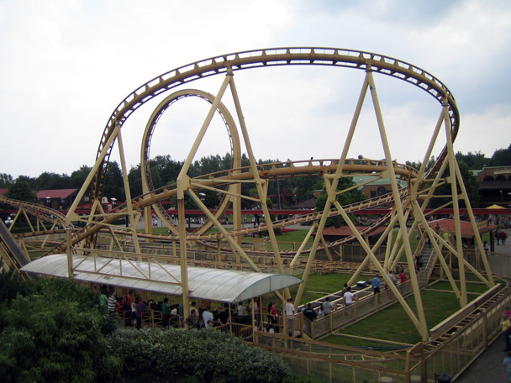
Knikker Achtbaan

Naam:_______________________________________________________________________________

Namen van je groepje: _____________________________________________________________________________________________________________________________________________________________________________________________________________________________________________________________________

Datum: _____________________________________________________________________________

Bekijk de webquest. (Opdracht op internet)
In dit boekje staat wanneer jullie wat moeten doen.
Volg steeds de stappen en vul dingen in.
- Lees: Knikker achtbaan.
- Stap 1
- Verzamel alle onderdelen die jullie nodig hebben.
- Schrijf hieronder de zes vragen over het materiaal, wat jullie graag willen weten om de knikkerbaan te bouwen. Als je het antwoord te weten bent gekomen schrijf je die ook op.
Vraag 1: ____________________________________________________________________________________________________________________________________________________________________________________________________________________________________________________________________________________________________________________________________________________________________________________________
Antwoord vraag 1:
____________________________________________________________________________________________________________________________________________________________________________________________________________________________________________________________________________________________________________________________________________________________________________________________

Vraag 2:
____________________________________________________________________________________________________________________________________________________________________________________________________________________________________________________________________________________________________________________________________________________________________________________________
Antwoord vraag 2:
____________________________________________________________________________________________________________________________________________________________________________________________________________________________________________________________________________________________________________________________________________________________________________________________

Vraag 3:
____________________________________________________________________________________________________________________________________________________________________________________________________________________________________________________________________________________________________________________________________________________________________________________________
Antwoord vraag 3:
____________________________________________________________________________________________________________________________________________________________________________________________________________________________________________________________________________________________________________________________________________________________________________________________

Vraag 4:
____________________________________________________________________________________________________________________________________________________________________________________________________________________________________________________________________________________________________________________________________________________________________________________________
Antwoord vraag 4:
____________________________________________________________________________________________________________________________________________________________________________________________________________________________________________________________________________________________________________________________________________________________________________________________

Vraag 5:
____________________________________________________________________________________________________________________________________________________________________________________________________________________________________________________________________________________________________________________________________________________________________________________________
Antwoord vraag 5:
____________________________________________________________________________________________________________________________________________________________________________________________________________________________________________________________________________________________________________________________________________________________________________________________

Vraag 6:
____________________________________________________________________________________________________________________________________________________________________________________________________________________________________________________________________________________________________________________________________________________________________________________________
Antwoord vraag 6:
____________________________________________________________________________________________________________________________________________________________________________________________________________________________________________________________________________________________________________________________________________________________________________________________

- Stap 2: ontwerpen achtbaan. (10 minuten)
- Stap 3: bouwen achtbaan. (60 minuten)
Wat is het thema/onderwerp van jullie knikker achtbaan?
Bedenk dat het bij een pretpark moet passen.
________________________________________________________________________________________________________________________________________________________________________________________________________________________________________________________________________________________________________________

- Stap 4: keuring achtbaan. (10 minuten)
Dit vult jullie groepje zelf in:
 |  | Omcirkel en/of vul in.
Iedereen in het groepje doet evenveel. | JA |  | NEE
Jullie groepje heeft materialen gebruikt die jullie mochten gebruiken. | JA |  | NEE
Jullie achtbaan past op zes a4tjes.  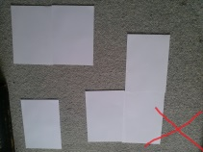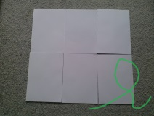 | JA |  | NEE
De knikker wordt alleen in het begin aangeraakt.  De knikker rolt zelf door de rest van de knikker achtbaan. | JA |  | NEE
Het duurt minimaal 10 seconden dat de knikker van het begin tot einde onderweg is. | JA |  | NEE | Hoelang?  ____ seconden.
De knikker achtbaan heeft een thema/onderwerp | JA |  | NEE | Welke?  __________________
De knikker achtbaan heeft een naam. | JA |  | NEE | Naam:  ___________________

Dit vult een andere groepje van jullie knikker achtbaan in:
 |  | Omcirkel en/of vul in.
Iedereen in het groepje doet evenveel. | JA |  | NEE
Het groepje heeft materialen gebruikt die jullie mochten gebruiken. | JA |  | NEE
De achtbaan past op zes a4tjes. | JA |  | NEE
De knikker wordt alleen in het begin aangeraakt.  De knikker rolt zelf door de rest van de knikker achtbaan. | JA |  | NEE
Het duurt minimaal 10 seconden dat de knikker van het begin tot einde onderweg is. | JA |  | NEE | Hoelang?  ____ seconden.
De knikker achtbaan heeft een thema/onderwerp | JA |  | NEE | Welke?  __________________
De knikker achtbaan heeft een naam. | JA |  | NEE | Naam:  ___________________

- Stap 5: filmpje maken. (5 minuten)
Sla het filmpje op, deze ga je naar Angelique sturen.
- Stap 6: mailen (20 minuten)
Jullie sturen een mail naar Angelique, let goed op wat er allemaal in moet staan.
Je kunt kladpapier gebruiken op de achterkant van dit werkboekje.
Doe het samen of verdeel de vragen.

Hoe is het gegaan met het doen van alle stappen?
Ik ben erg benieuwd of alles is gelukt, en hoe jullie knikker achtbaan is geworden.
Om je in te schrijven voor de wedstrijd moet je als bewijs mij een mail sturen met de volgende dingen:
1. Wie hebben de knikker achtbaan gemaakt?
2. Hoe ging het maken?
3. Wat ging goed?
4. Wat kon beter?
5. Wat is de naam van jullie knikker achtbaan?
6. Wat ging er goed met de samenwerking?
7. Wat kon beter met het samenwerken?
8. Waarom moet jullie achtbaan gekozen worden als de mooiste achtbaan?
9. Waar moeten ze op letten bij het bouwen van deze achtbaan?
10. Graag wil ik ook het filmpje zien van de knikker achtbaan!
11. Lever je werkboek in bij jullie juf, zij stuurt die naar mij op zodat ik alles goed kan bekijken!
Mijn mail is: DirecteurSlagharen11@gmail.com
Ik ben benieuwd naar jullie ontwerpen van de achtbaan!
Wanneer iedereen die meedoet is geweest laat ik weten wie gewonnen heeft!

- Opruimen (8 minuten)
Ruim al het materiaal op, behalve de knikkerbaan.
Geef de knikkers terug aan jullie juf.

Binnenkort horen jullie van Angelique wie gewonnen heeft!

________________________________________________________________________________________________________________________________________________________________________________________________________________________________________________________________________________________________________________________________________________________________________________________________________________________________________________________________________________________________________________________________________________________________________________________________________________________________________________________________________________________________________________________________________________________________________________________________________________________________________________________________________________________________________________________________________________________________________________________________________________________________________________________________________________________________________________________________________________________________________________________________________________________________________________________________________________________________________________________________________________________________________________________________________________________________________________________________________________________________________________________________________________________________________________________________________________________________________________________________________________________________________________________________________________________________________________________________________________________________________________________________________________________________________________________________________________________________________________________________________________________________________________________________________________________________________________________________________________________________________________________________________________________________________________________________________________________________________________________________________________________________________________________________________________________________________________________________________________________________________________________________________________________________________________________________________________________________________________________________________________________________________________________________________________________________________________________________________________________________________________________________________________________________________________________________________________________________________________________________________________________________________________________________________________________________________________________________________________________________________________________________________________________________________________________________________________________________________________________________________________________________________________________________________________________________________________________________________________________________________________________________________________________________________________________________________________________________________________________________________________________________________________________________________________________
________________________________________________________________________________________________________________________________________________________________________________________________________________________________________________________________________________________________________________________________________________________________________________________________________________________________________________________________________________________________________________________________________________________________________________________________________________________________________________________________________________________________________________________________________________________________________________________________________________________________________________________________________________________________________________________________________________________________________________________________________________________________________________________________________________________________________________________________________________________________________________________________________________________________________________________________________________________________________________________________________________________________________________________________________________________________________________________________________________________________________________________________________________________________________________________________________________________________________________________________________________________________________________________________________________________________________________________________________________________________________________________________________________________________________________________________________________________________________________________________________________________________________________________________________________________________________________________________________________________________________________________________________________________________________________________________________________________________________________________________________________________________________________________________________________________________________________________________________________________________________________________________________________________________________________________________________________________________________________________________________________________________________________________________________________________________________________________________________________________________________________________________________________________________________________________________________________________________________________________________________________________________________________________________________________________________________________________________________________________________________________________________________________________________________________________________________________________________________________________________________________________________________________________________________________________________________________________________________________________________________________________________________________________________________________________________________________________________________________________________________________________________________________________________________________________

